Федеральное государственное автономное образовательное учреждение высшего образования

Университет ИТМО

**Отчет по лабораторной работе №5**

**«Администрирование систем и сетей»**

**Выполнили:**

Чжоу Хунсян

Группа: P34131

**Желаемая оценка: 3**

**Преподаватель:**

Афанасьев Дмитрий Борисович

2024 г.

Санкт-Петербург

**Оглавление**

ACL Configuration 错误!未定义书签。

Цели 3

Топология 3

План работы 3

Процедура конфигурирования 5

Шаг 1. 5

Шаг 2. 5

Шаг 3. 6

Шаг 4. 7

Проверка 8

Справочные конфигурации 9

Настройка локального механизма AAA 错误!未定义书签。

Цели **错误!未定义书签。**

Топология **错误!未定义书签。**

План работы **错误!未定义书签。**

Процедура конфигурирования **错误!未定义书签。**

Шаг 1. **错误!未定义书签。**

Шаг 2. **错误!未定义书签。**

Шаг 3. **错误!未定义书签。**

Шаг 4. **错误!未定义书签。**

Шаг 5. **错误!未定义书签。**

Справочные конфигурации **错误!未定义书签。**

Вывод 17

# Создание WLAN

## Цели

Лабораторная работа помогает получить практические навыки по изучению

следующих тем:

* Процедура аутентификации точек доступа
* Процедура настройки профилей WLAN
* Процесс настройки основных параметров WLAN

## Топология

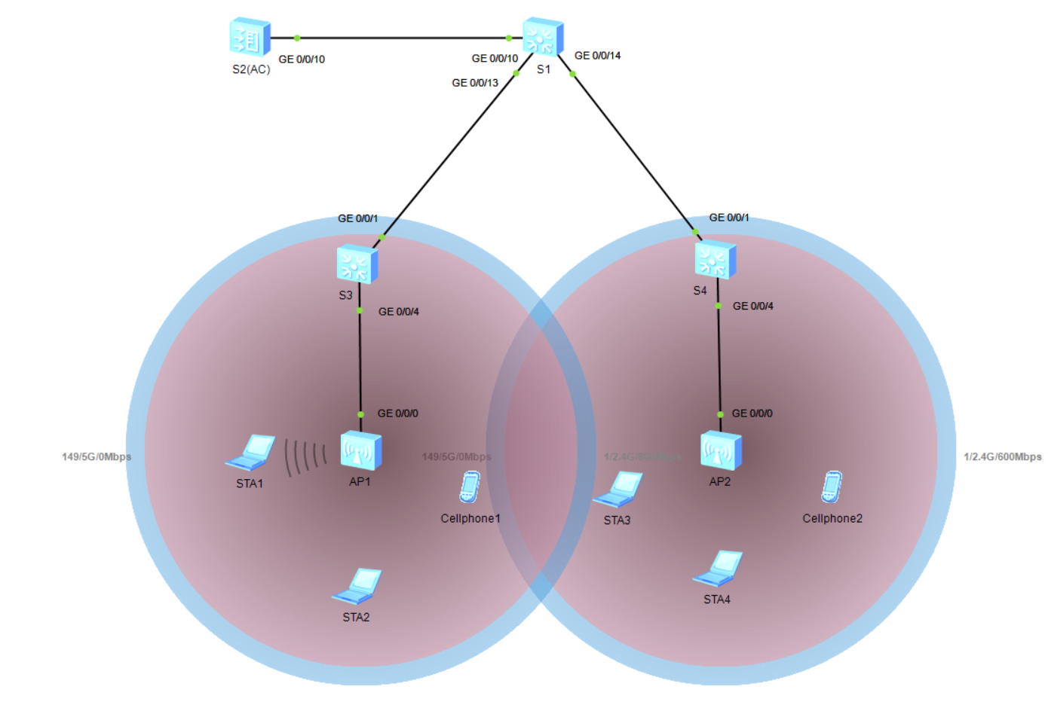

## План работы

1. Настройка подключения к проводной сети.
2. Настройка точек доступа и перевод их в режим онлайн.
   1. Создание групп точек доступа и добавление точек доступа с одинаковой
3. конфигурацией в одну группу для унифицированной настройки.
   1. Настройка системных параметров контроллера доступа, включая код страны
4. и интерфейс-источник, используемый контроллером для связи с точками
5. доступа.
   1. Настройка режима аутентификации AP и импорт AP для выхода точек
6. доступа в сеть.
7. Настройка параметров сервисов WLAN и передача конфигурации точкам
8. доступа, чтобы обеспечить доступ STA к WLAN.

## Процедура конфигурирования

### Шаг 1. Настройте основные параметры устройства.

# Присвойте имена устройствам (назовите S2 в топологии AC).

<Huawei>system-view

Enter system view, return user view with Ctrl+Z.

[Huawei]sysname S1

[S1]

<AC6605>system-view

Enter system view, return user view with Ctrl+Z.

[AC6605]sysname AC

[AC]

<Huawei>system-view

Enter system view, return user view with Ctrl+Z.

[Huawei]sysname S3

[S3]

<Huawei>system-view

Enter system view, return user view with Ctrl+Z.

[Huawei]sysname S4

[S4]

# Отключите ненужные порты между S1 и AC. Этот шаг можно выполнять только в среде, описанной в Руководстве по выполнению лабораторных работ для подготовки к сертификации HCIA-Datacom V1.0.

[S1]interface g0/0/11

[S1-GigabitEthernet0/0/11]shutdown

[S1-GigabitEthernet0/0/11]interface g0/0/12

[S1-GigabitEthernet0/0/12]shutdown

# Включите функцию PoE на портах S3 и S4, подключенных к точкам доступа.

### Шаг 2. Настройте параметры проводной сети.

# Настройте VLAN.

[S1]vlan batch 100 101

Info: This operation may take a few seconds. Please wait for a moment...done.

[S1]interface g0/0/13

[S1-GigabitEthernet0/0/13]port link-type trunk

[S1-GigabitEthernet0/0/13]port trunk allow-pass vlan 100 101

[S1-GigabitEthernet0/0/13]quit

[S1]interface g0/0/14

[S1-GigabitEthernet0/0/14]port link-type trunk

[S1-GigabitEthernet0/0/14]port trunk allow-pass vlan 100 101

[S1-GigabitEthernet0/0/14]quit

[S1]interface g0/0/10

[S1-GigabitEthernet0/0/10]port link-type trunk

[S1-GigabitEthernet0/0/10]port trunk allow-pass vlan 100 101

[S1-GigabitEthernet0/0/10]quit

[AC]vlan batch 100 101

Info: This operation may take a few seconds. Please wait for a moment...done.

[AC]interface g0/0/10

[AC-GigabitEthernet0/0/10]port link-type trunk.

[AC-GigabitEthernet0/0/10]port trunk allow-pass vlan 100 101

[AC-GigabitEthernet0/0/10]quit

[S3]vlan batch 100 101

Info: This operation may take a few seconds. Please wait for a moment...done.

[S3]interface g0/0/1

[S3-GigabitEthernet0/0/1]port link-type trunk

[S3-GigabitEthernet0/0/1]port trunk allow-pass vlan 100 101

[S3-GigabitEthernet0/0/1]quit

[S3]interface g0/0/4

[S3-GigabitEthernet0/0/4]port link-type trunk

[S3-GigabitEthernet0/0/4]port trunk pvid vlan 100

[S3-GigabitEthernet0/0/4]port trunk allow-pass vlan 100 101

[S3-GigabitEthernet0/0/4]quit

[S4]vlan batch 100 101

Info: This operation may take a few seconds. Please wait for a moment...done.

[S4]interface g0/0/1

[S4-GigabitEthernet0/0/1]port link-type trunk

[S4-GigabitEthernet0/0/1]port trunk allow-pass vlan 100 to 101

[S4-GigabitEthernet0/0/1]quit

[S4]interface g0/0/4

[S4-GigabitEthernet0/0/4]port link-type trunk

[S4-GigabitEthernet0/0/4]port trunk pvid vlan 100

[S4-GigabitEthernet0/0/4]port trunk allow-pass vlan 100 to 101

[S4-GigabitEthernet0/0/4]quit

# Настройте IP-адреса интерфейсов.

[S1]interface Vlanif 101

[S1-Vlanif101]ip addr 192.168.101.254 24

[S1-Vlanif101]quit

[S1]interface LoopBack 0

[S1-LoopBack0] ip address 10.0.1.1 32

[S1-LoopBack0]quit

[AC]interface Vlanif 100

[AC-Vlanif100]ip addr 192.168.100.254 24

# Настройте DHCP.

[S1]dhcp enable

Info: The operation may take a few seconds. Please wait for a moment.done.

[S1]ip pool sta

Info:It's successful to create an IP address pool.

[S1-ip-pool-sta]network 192.168.101.0 mask 24

[S1-ip-pool-sta]gateway-list 192.168.101.254

[S1-ip-pool-sta]quit [S1]interface Vlanif 101

[S1-Vlanif101]dhcp select global

[S1-Vlanif101]quit

[AC]dhcp enable

Info: The operation may take a few seconds. Please wait for a moment.done.

[AC]ip pool ap

Info: It is successful to create an IP address pool.

[AC-ip-pool-ap]network 192.168.100.254 mask 24

[AC-ip-pool-ap]gateway-list 192.168.100.254

[AC-ip-pool-ap]quit

[AC]interface Vlanif 100

[AC-Vlanif100]dhcp select global

[AC-Vlanif100]quit

### Шаг 3. Настройте параметры точек доступа для выхода в сеть.

# Создайте группу AP и назовите ее ap-group1.

[AC]wlan

[AC-wlan-view]ap-group name ap-group1

Info: This operation may take a few seconds. Please wait for a moment.done.

[AC-wlan-ap-group-ap-group1]quit

# Создайте профиль регулирующего домена и настройте код страны AC в профиле.

[AC]wlan

[AC-wlan-view]regulatory-domain-profile name default

[AC-wlan-regulate-domain-default]country-code on

Error: The country code is invalid.

# Установите привязку профиля регулирующего домена к группе AP.

[AC]wlan

[AC-wlan-view]ap-group name ap-group1

[AC-wlan-ap-group-ap-group1]regulatory-domain-profile default

Warning: Modifying the country code will clear channel, power and antenna gain c

onfigurations of the radio and reset the AP. Continue?[Y/N]:Y

[AC-wlan-ap-group-ap-group1]quit

# Укажите интерфейс-источник на AC для установления туннелей CAPWAP.

[AC]capwap source interface Vlanif 100

# Импортируйте точки доступа в AC и добавьте их в группу AP с именем ap-group1.

[AC]wlan

[AC-wlan-view]ap auth-mode mac-auth

[AC-wlan-view]ap-id 0 ap-mac 00e0-fc57-02f0

[AC-wlan-ap-0]ap-name ap1

[AC-wlan-ap-0]ap-group ap-group1

Warning: This operation may cause AP reset. If the country code changes, it will clear channel, power and antenna gain configurations of the radio, Whether to continue? [Y/N]:Y

[AC-wlan-ap-0]quit

[AC-wlan-view]ap-id 1 ap-mac 00e0-fc3b-07c0

[AC-wlan-ap-1]ap-name ap2

[AC-wlan-ap-1]ap-group ap-group1

Warning: This operation may cause AP reset. If the country code changes, it will clear channel, power and antenna gain configurations of the radio, Whether to continue? [Y/N]:Y

[AC-wlan-ap-1]quit

# Выведите на экран информацию о текущей AP.

[AC]wlan

[AC-wlan-view]display ap all

Info: This operation may take a few seconds. Please wait for a moment.done.

Total AP information:

nor : normal [2]

--------------------------------------------------------------------------------

--------------

ID MAC Name Group IP Type State STA Upt

ime

--------------------------------------------------------------------------------

--------------

0 00e0-fc57-02f0 ap1 ap-group1 192.168.100.198 AP2050DN nor 1 7M:

55S

1 00e0-fc3b-07c0 ap2 ap-group1 192.168.100.190 AP2050DN nor 0 8M:

33S

--------------------------------------------------------------------------------

--------------

Total: 2

### Шаг 4. Настройте параметры сервисов WLAN.

# Создайте профиль безопасности HCIA-WLAN и настройте политику безопасности.

[AC-wlan-view]security-profile name HCIA-WLAN

[AC-wlan-sec-prof-HCIA-WLAN]security wpa-wpa2 psk pass-phrase HCIA-Datacom aes

[AC-wlan-sec-prof-HCIA-WLAN]quit

# Создайте профиль SSID HCIA-WLAN и задайте имя SSID HCIA-WLAN.

[AC-wlan-view]ssid-profile name HCIA-WLAN

[AC-wlan-ssid-prof-HCIA-WLAN]ssid HCIA-WLAN

Info: This operation may take a few seconds, please wait.done.

[AC-wlan-ssid-prof-HCIA-WLAN]quit

# Создайте профиль VAP HCIA-WLAN, настройте режим передачи данных и сервисную VLAN и примените профиль безопасности и профиль SSID к профилю VAP.

[AC-wlan-view]vap-profile name HCIA-WLAN

[AC-wlan-vap-prof-HCIA-WLAN]forward-mode direct-forward

[AC-wlan-vap-prof-HCIA-WLAN]service-vlan vlan-id 101

Info: This operation may take a few seconds, please wait.done.

[AC-wlan-vap-prof-HCIA-WLAN]security-profile HCIA-WLAN

Info: This operation may take a few seconds, please wait.done.

[AC-wlan-vap-prof-HCIA-WLAN]ssid-profile HCIA-WLAN

Info: This operation may take a few seconds, please wait.done.

[AC-wlan-vap-prof-HCIA-WLAN]quit

# Установите привязку профиля VAP к группе AP и примените конфигурацию профиля VAP HCIA-WLAN к радиомодулю 0 и радиомодулю 1 точек доступа в группе AP.

[AC-wlan-view]ap-group name ap-group1

[AC-wlan-ap-group-ap-group1]vap-profile HCIA-WLAN wlan 1 radio all

Info: This operation may take a few seconds, please wait...done.

## Проверка

Перед проверкой нужно подключиться к WLAN

Пароль: HCIA-Datacom

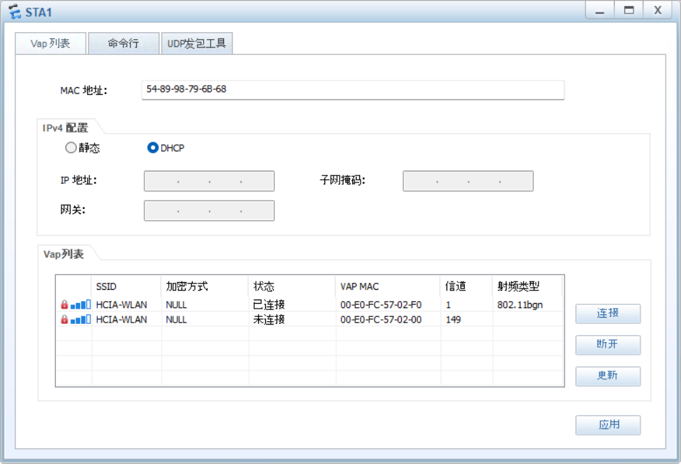

STA>ping 10.0.1.1

Ping 10.0.1.1: 32 data bytes, Press Ctrl_C to break

From 10.0.1.1: bytes=32 seq=1 ttl=255 time=141 ms

From 10.0.1.1: bytes=32 seq=2 ttl=255 time=156 ms

From 10.0.1.1: bytes=32 seq=3 ttl=255 time=140 ms

From 10.0.1.1: bytes=32 seq=4 ttl=255 time=141 ms

From 10.0.1.1: bytes=32 seq=5 ttl=255 time=156 ms

--- 10.0.1.1 ping statistics ---

5 packet(s) transmitted

5 packet(s) received

0.00% packet loss

round-trip min/avg/max = 140/146/156 ms

[AC]display station all

Rf/WLAN: Radio ID/WLAN ID

Rx/Tx: link receive rate/link transmit rate(Mbps)

--------------------------------------------------------------------------------

----------------------

STA MAC AP ID Ap name Rf/WLAN Band Type Rx/Tx RSSI VLAN IP a

ddress SSID

--------------------------------------------------------------------------------

----------------------

5489-9879-6b68 0 ap1 0/1 2.4G - -/- - 101 192.

168.101.253 HCIA-WLAN

--------------------------------------------------------------------------------

----------------------

Total: 1 2.4G: 1 5G: 0

## Справочные конфигурации

S1

*#*

sysname S1

*#*

vlan batch 100 to 101

*#*

cluster enable

ntdp enable

ndp enable

*#*

drop illegal-mac alarm

*#*

dhcp enable

*#*

diffserv domain default

*#*

drop-profile default

*#*

ip pool sta

 gateway-list 192.168.101.254

 network 192.168.101.0 mask 255.255.255.0

*#*

aaa

 authentication-scheme default

 authorization-scheme default

 accounting-scheme default

 domain default

 domain default_admin

 local-user admin password simple admin

 local-user admin service-type http

*#*

interface Vlanif1

*#*

interface Vlanif100

*#*

interface Vlanif101

 ip address 192.168.101.254 255.255.255.0

 dhcp select global

*#*

interface MEth0/0/1

*#*

interface GigabitEthernet0/0/1

*#*

interface GigabitEthernet0/0/2

*#*

interface GigabitEthernet0/0/3

*#*

interface GigabitEthernet0/0/4

*#*

interface GigabitEthernet0/0/5

*#*

interface GigabitEthernet0/0/6

*#*

interface GigabitEthernet0/0/7

*#*

interface GigabitEthernet0/0/8

*#*

interface GigabitEthernet0/0/9

*#*

interface GigabitEthernet0/0/10

 port link-type trunk

 port trunk allow-pass vlan 100 to 101

*#*

interface GigabitEthernet0/0/11

 shutdown

*#*

interface GigabitEthernet0/0/12

 shutdown

*#*

interface GigabitEthernet0/0/13

 port link-type trunk

 port trunk allow-pass vlan 100 to 101

*#*

interface GigabitEthernet0/0/14

 port link-type trunk

 port trunk allow-pass vlan 100 to 101

*#*

interface GigabitEthernet0/0/15

*#*

interface GigabitEthernet0/0/16

*#*

interface GigabitEthernet0/0/17

*#*

interface GigabitEthernet0/0/18

*#*

interface GigabitEthernet0/0/19

*#*

interface GigabitEthernet0/0/20

*#*

interface GigabitEthernet0/0/21

*#*

interface GigabitEthernet0/0/22

*#*

interface GigabitEthernet0/0/23

*#*

interface GigabitEthernet0/0/24

*#*

interface NULL0

*#*

interface LoopBack0

 ip address 10.0.1.1 255.255.255.255

*#*

user-interface con 0

user-interface vty 0 4

*#*

return

S2(AC)

[V200R007C10SPC300]

*#*

 sysname AC

*#*

 set memory-usage threshold 0

*#*

ssl renegotiation-rate 1

*#*

vlan batch 100 to 101

*#*

authentication-profile name default_authen_profile

authentication-profile name dot1x_authen_profile

authentication-profile name mac_authen_profile

authentication-profile name portal_authen_profile

authentication-profile name macportal_authen_profile

*#*

dhcp enable

*#*

diffserv domain default

*#*

radius-server template default

*#*

pki realm default

 rsa local-key-pair default

 enrollment self-signed

*#*

ike proposal default

 encryption-algorithm aes-256

 dh group14

 authentication-algorithm sha2-256

 authentication-method pre-share

 integrity-algorithm hmac-sha2-256

 prf hmac-sha2-256

*#*

free-rule-template name default_free_rule

*#*

portal-access-profile name portal_access_profile

*#*

ip pool ap

 gateway-list 192.168.100.254

 network 192.168.100.0 mask 255.255.255.0

*#*

aaa

 authentication-scheme default

 authentication-scheme radius

  authentication-mode radius

 authorization-scheme default

 accounting-scheme default

 domain default

  authentication-scheme radius

  radius-server default

 domain default_admin

  authentication-scheme default

 local-user admin password irreversible-cipher $1a$WYts3za|>U$j_R~7~aOu<x(P{7oJs35+jAJF@^`$G`5w[Q-kgpC$

 local-user admin privilege level 15

 local-user admin service-type http

*#*

interface Vlanif100

 ip address 192.168.100.254 255.255.255.0

 dhcp select global

*#*

interface MEth0/0/1

 undo negotiation auto

 duplex half

*#*

interface GigabitEthernet0/0/1

*#*

interface GigabitEthernet0/0/2

*#*

interface GigabitEthernet0/0/3

*#*

interface GigabitEthernet0/0/4

*#*

interface GigabitEthernet0/0/5

*#*

interface GigabitEthernet0/0/6

*#*

interface GigabitEthernet0/0/7

*#*

interface GigabitEthernet0/0/8

*#*

interface GigabitEthernet0/0/9

*#*

interface GigabitEthernet0/0/10

 port link-type trunk

 port trunk allow-pass vlan 100 to 101

*#*

interface GigabitEthernet0/0/11

*#*

interface GigabitEthernet0/0/12

*#*

interface GigabitEthernet0/0/13

*#*

interface GigabitEthernet0/0/14

*#*

interface GigabitEthernet0/0/15

*#*

interface GigabitEthernet0/0/16

*#*

interface GigabitEthernet0/0/17

*#*

interface GigabitEthernet0/0/18

*#*

interface GigabitEthernet0/0/19

*#*

interface GigabitEthernet0/0/20

*#*

interface GigabitEthernet0/0/21

 undo negotiation auto

 duplex half

*#*

interface GigabitEthernet0/0/22

 undo negotiation auto

 duplex half

*#*

interface GigabitEthernet0/0/23

 undo negotiation auto

 duplex half

*#*

interface GigabitEthernet0/0/24

 undo negotiation auto

 duplex half

*#*

interface XGigabitEthernet0/0/1

*#*

interface XGigabitEthernet0/0/2

*#*

interface NULL0

*#*

 snmp-agent local-engineid 800007DB03000000000000

 snmp-agent

*#*

ssh server secure-algorithms cipher aes256_ctr aes128_ctr

ssh server key-exchange dh_group14_sha1

ssh client secure-algorithms cipher aes256_ctr aes128_ctr

ssh client secure-algorithms hmac sha2_256

ssh client key-exchange dh_group14_sha1

*#*

capwap source interface vlanif100

*#*

user-interface con 0

 authentication-mode password

user-interface vty 0 4

 protocol inbound all

user-interface vty 16 20

 protocol inbound all

*#*

wlan

 traffic-profile name default

 security-profile name default

 security-profile name HCIA-WLAN

  security wpa-wpa2 psk pass-phrase %^%*#L~boRa20b%rr~z=17{Y6~}iz<}(<v)1s2N@Y2Ow<%^%# aes*

 security-profile name default-wds

 security-profile name default-mesh

 ssid-profile name default

 ssid-profile name HCIA-WLAN

  ssid HCIA-WLAN

 vap-profile name default

 vap-profile name HCIA-WLAN

  service-vlan vlan-id 101

  ssid-profile HCIA-WLAN

  security-profile HCIA-WLAN

 wds-profile name default

 mesh-handover-profile name default

 mesh-profile name default

 regulatory-domain-profile name default

 air-scan-profile name default

 rrm-profile name default

 radio-2g-profile name default

 radio-5g-profile name default

 wids-spoof-profile name default

 wids-profile name default

 wireless-access-specification

 ap-system-profile name default

 port-link-profile name default

 wired-port-profile name default

 serial-profile name preset-enjoyor-toeap

 ap-group name default

 ap-group name ap-group1

  radio 0

   vap-profile HCIA-WLAN wlan 1

  radio 1

   vap-profile HCIA-WLAN wlan 1

  radio 2

   vap-profile HCIA-WLAN wlan 1

 ap-id 0 type-id 69 ap-mac 00e0-fc57-02f0 ap-sn 2102354483102F681B1A

  ap-name ap1

  ap-group ap-group1

 ap-id 1 type-id 69 ap-mac 00e0-fc3b-07c0 ap-sn 2102354483106B77715E

  ap-name ap2

  ap-group ap-group1

 provision-ap

*#*

dot1x-access-profile name dot1x_access_profile

*#*

mac-access-profile name mac_access_profile

*#*

return

S3

*#*

sysname S3

*#*

vlan batch 100 to 101

*#*

cluster enable

ntdp enable

ndp enable

*#*

drop illegal-mac alarm

*#*

diffserv domain default

*#*

drop-profile default

*#*

aaa

 authentication-scheme default

 authorization-scheme default

 accounting-scheme default

 domain default

 domain default_admin

 local-user admin password simple admin

 local-user admin service-type http

*#*

interface Vlanif1

*#*

interface MEth0/0/1

*#*

interface GigabitEthernet0/0/1

 port link-type trunk

 port trunk allow-pass vlan 100 to 101

*#*

interface GigabitEthernet0/0/2

*#*

interface GigabitEthernet0/0/3

*#*

interface GigabitEthernet0/0/4

 port link-type trunk

 port trunk pvid vlan 100

 port trunk allow-pass vlan 100 to 101

*#*

interface GigabitEthernet0/0/5

*#*

interface GigabitEthernet0/0/6

*#*

interface GigabitEthernet0/0/7

*#*

interface GigabitEthernet0/0/8

*#*

interface GigabitEthernet0/0/9

*#*

interface GigabitEthernet0/0/10

*#*

interface GigabitEthernet0/0/11

*#*

interface GigabitEthernet0/0/12

*#*

interface GigabitEthernet0/0/13

*#*

interface GigabitEthernet0/0/14

*#*

interface GigabitEthernet0/0/15

*#*

interface GigabitEthernet0/0/16

*#*

interface GigabitEthernet0/0/17

*#*

interface GigabitEthernet0/0/18

*#*

interface GigabitEthernet0/0/19

*#*

interface GigabitEthernet0/0/20

*#*

interface GigabitEthernet0/0/21

*#*

interface GigabitEthernet0/0/22

*#*

interface GigabitEthernet0/0/23

*#*

interface GigabitEthernet0/0/24

*#*

interface NULL0

*#*

user-interface con 0

user-interface vty 0 4

*#*

return

S4

*#*

sysname S4

*#*

vlan batch 100 to 101

*#*

cluster enable

ntdp enable

ndp enable

*#*

drop illegal-mac alarm

*#*

diffserv domain default

*#*

drop-profile default

*#*

aaa

 authentication-scheme default

 authorization-scheme default

 accounting-scheme default

 domain default

 domain default_admin

 local-user admin password simple admin

 local-user admin service-type http

*#*

interface Vlanif1

*#*

interface MEth0/0/1

*#*

interface GigabitEthernet0/0/1

 port link-type trunk

 port trunk allow-pass vlan 100 to 101

*#*

interface GigabitEthernet0/0/2

*#*

interface GigabitEthernet0/0/3

*#*

interface GigabitEthernet0/0/4

 port link-type trunk

 port trunk pvid vlan 100

 port trunk allow-pass vlan 100 to 101

*#*

interface GigabitEthernet0/0/5

*#*

interface GigabitEthernet0/0/6

*#*

interface GigabitEthernet0/0/7

*#*

interface GigabitEthernet0/0/8

*#*

interface GigabitEthernet0/0/9

*#*

interface GigabitEthernet0/0/10

*#*

interface GigabitEthernet0/0/11

*#*

interface GigabitEthernet0/0/12

*#*

interface GigabitEthernet0/0/13

*#*

interface GigabitEthernet0/0/14

*#*

interface GigabitEthernet0/0/15

*#*

interface GigabitEthernet0/0/16

*#*

interface GigabitEthernet0/0/17

*#*

interface GigabitEthernet0/0/18

*#*

interface GigabitEthernet0/0/19

*#*

interface GigabitEthernet0/0/20

*#*

interface GigabitEthernet0/0/21

*#*

interface GigabitEthernet0/0/22

*#*

interface GigabitEthernet0/0/23

*#*

interface GigabitEthernet0/0/24

*#*

interface NULL0

*#*

user-interface con 0

user-interface vty 0 4

*#*

return

# Вывод

В ходе выполнения данной лабораторной работы мы сконфигурировали WLAN с помощью контроллера доступа (AC) и точек доступа AP, чтобы обеспечить доступ STA к WLAN.